SEC Form 4

FORM 4

Check this box if no longer subject to Section 16. Form 4 or Form 5 obligations may continue. See Instruction 1(b).

UNITED STATES SECURITIES AND EXCHANGE COMMISSION
Washington, D.C. 20549
 |  | OMB APPROVAL
STATEMENT OF CHANGES IN BENEFICIAL OWNERSHIP
 |  | OMB Number: | 3235-0287
 |  | Estimated average burden
Filed pursuant to Section 16(a) of the Securities Exchange Act of 1934 |  | hours per response: | 0.5
or Section 30(h) of the Investment Company Act of 1940
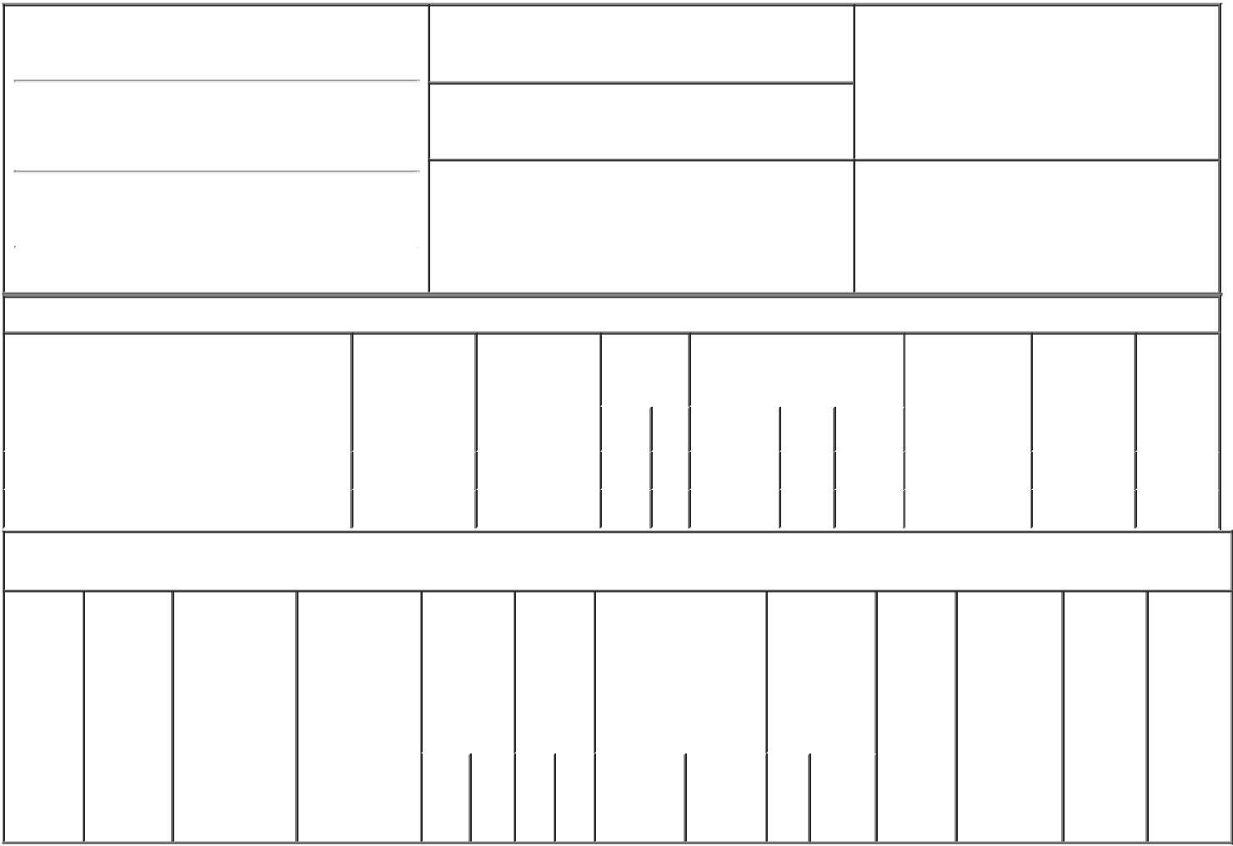

1. Name and Address of Reporting Person*
Clary Rebecca

(Last) (First) (Middle)

1351 HOLIDAY SQUARE BLVD.

2. Issuer Name and Ticker or Trading Symbol

Globalstar, Inc. [ GSAT ]

3. Date of Earliest Transaction (Month/Day/Year)

12/06/2021

- Relationship of Reporting Person(s) to Issuer (Check all applicable)

 | Director | 10% Owner
X | Officer (give title | Other (specify
 | below) | below)

VP & Chief Financial Officer

(Street)
 | COVINGTON | LA | 70433
 | (City) | (State) | (Zip)

4. If Amendment, Date of Original Filed (Month/Day/Year) 6. Individual or Joint/Group Filing (Check Applicable
Line)
X Form filed by One Reporting Person

Form filed by More than One Reporting
Person

Table I - Non-Derivative Securities Acquired, Disposed of, or Beneficially Owned

 | 1. Title of Security (Instr. 3) | 2. Transaction | 2A. Deemed | 3. | 4. Securities Acquired (A) or |  |  | 5. Amount of | 6. Ownership | 7. Nature
 |  | Date | Execution Date, | Transaction | Disposed Of (D) (Instr. 3, 4 and |  |  | Securities | Form: Direct | of Indirect
 |  | (Month/Day/Year) | if any | Code (Instr. | 5) |  |  | Beneficially | (D) or Indirect | Beneficial
 |  |  | (Month/Day/Year) | 8) |  |  |  | Owned Following | (I) (Instr. 4) | Ownership
 |  |  |  |  |  |  |  | Reported |  | (Instr. 4)
 |  |  |  | Code V | Amount | (A) or | Price | Transaction(s)
 |  |  |  |  |  | (D) |  | (Instr. 3 and 4)
 | Voting Common Stock⁽¹⁾ | 12/06/2021 |  | F | 11,763 | D | $1.23 | 1,462,272⁽²⁾ | D
 | Voting Common Stock⁽³⁾ | 12/07/2021 |  | F | 11,759 | D | $1.32 | 1,450,513 | D

Table II - Derivative Securities Acquired, Disposed of, or Beneficially Owned

(e.g., puts, calls, warrants, options, convertible securities)

1. Title of | 2. | 3. Transaction | 3A. Deemed | 4. | 5. Number | 6. Date Exercisable and |  | 7. Title and | 8. Price of | 9. Number of | 10. | 11. Nature
Derivative | Conversion | Date | Execution Date, | Transaction | of | Expiration Date |  | Amount of | Derivative | derivative | Ownership | of Indirect
Security | or Exercise | (Month/Day/Year) | if any | Code (Instr. | Derivative | (Month/Day/Year) |  | Securities | Security | Securities | Form: | Beneficial
(Instr. 3) | Price of |  | (Month/Day/Year) | 8) | Securities |  |  | Underlying | (Instr. 5) | Beneficially | Direct (D) | Ownership
 | Derivative |  |  |  | Acquired |  |  | Derivative |  | Owned | or Indirect | (Instr. 4)
 | Security |  |  |  | (A) or |  |  | Security (Instr. |  | Following | (I) (Instr. 4)
 |  |  |  |  | Disposed |  |  | 3 and 4) |  | Reported
 |  |  |  |  | of (D) |  |  |  |  | Transaction(s)
 |  |  |  |  | (Instr. 3, 4 |  |  |  |  | (Instr. 4)
 |  |  |  |  | and 5)
 |  |  |  |  |  |  |  | Amount
 |  |  |  |  |  |  |  | or
 |  |  |  |  |  |  |  | Number
 |  |  |  |  |  | Date | Expiration | of
 |  |  |  | Code V | (A) (D) | Exercisable | Date | Title Shares

Explanation of Responses:

- Shares automatically withheld, based on the fair market value of the Common Stock on December 6, 2021, to pay required withholding taxes upon the vesting of a Restricted Stock Award under the Company's Equity Incentive Plan. The full award was previously reported.

- Includes 47,525 shares acquired under the Globalstar Employee Stock Purchase Plan on June 14, 2021, 63,895 shares acquired upon exercise of previously stock options under the Company's Equity Incentive Plan on September 9, 2021, and 15,344 shares acquired upon exercise of previously stock options under the Company's Equity Incentive Plan on October 12, 2021.
- Shares automatically withheld, based on the fair market value of the Common Stock on December 7, 2021, to pay required withholding taxes upon the vesting of a Restricted Stock Award under the Company's Equity Incentive Plan. The full award was previously reported.

Remarks:

/s/ Arthur McMahon, III,

attorney-in-fact for Rebecca 12/08/2021
Clary

** Signature of Reporting Person Date

Reminder: Report on a separate line for each class of securities beneficially owned directly or indirectly.

* If the form is filed by more than one reporting person, see Instruction 4 (b)(v).

- Intentional misstatements or omissions of facts constitute Federal Criminal Violations See 18 U.S.C. 1001 and 15 U.S.C. 78ff(a). Note: File three copies of this Form, one of which must be manually signed. If space is insufficient, see Instruction 6 for procedure.
Persons who respond to the collection of information contained in this form are not required to respond unless the form displays a currently valid OMB Number.

