SEC Form 4

FORM 4

Check this box if no longer subject to Section 16. Form 4 or Form 5 obligations may continue. See Instruction 1(b).

UNITED STATES SECURITIES AND EXCHANGE COMMISSION
Washington, D.C. 20549
 |  | OMB APPROVAL
STATEMENT OF CHANGES IN BENEFICIAL OWNERSHIP
 |  | OMB Number: | 3235-0287
 |  | Estimated average burden
Filed pursuant to Section 16(a) of the Securities Exchange Act of 1934 |  | hours per response: | 0.5
or Section 30(h) of the Investment Company Act of 1940
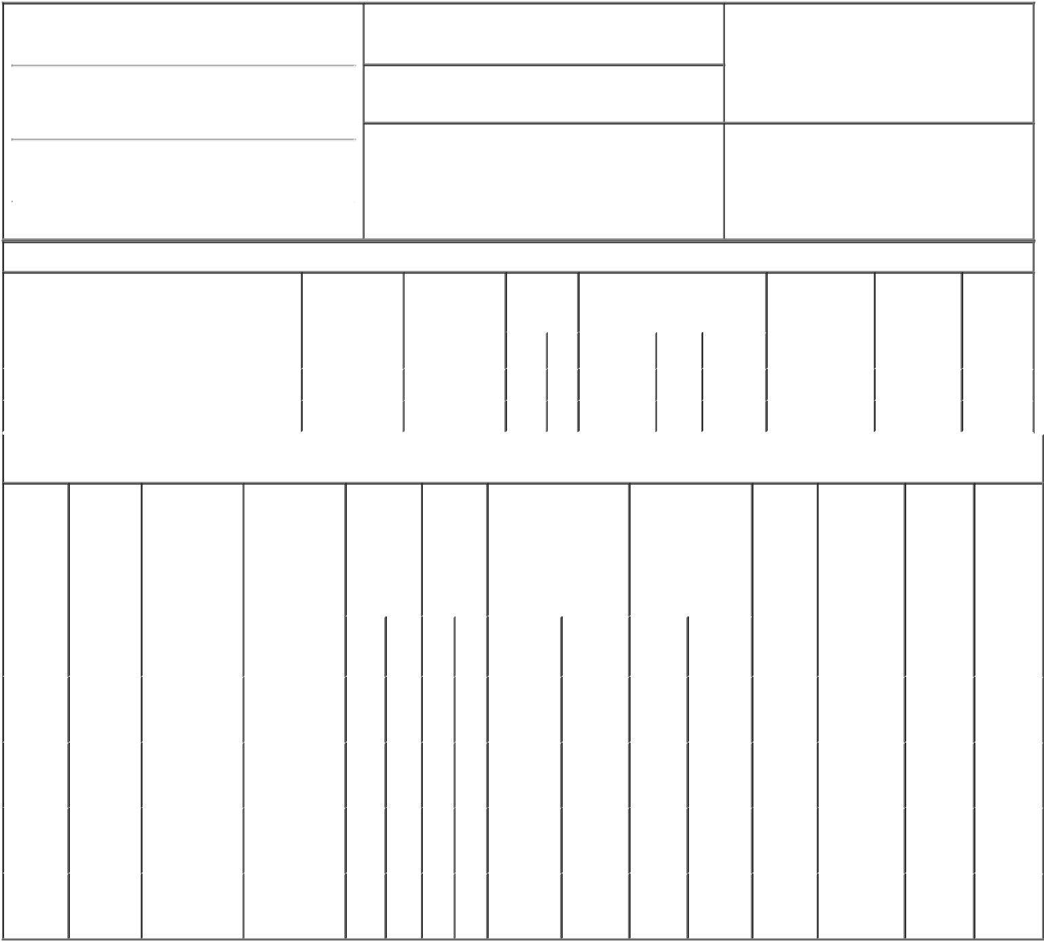

1. Name and Address of Reporting Person*
Kneuer John

(Last) (First) (Middle)

300 HOLIDAY SQUARE BLVD.

2. Issuer Name and Ticker or Trading Symbol

Globalstar, Inc. [ GSAT ]

3. Date of Earliest Transaction (Month/Day/Year)

03/01/2018

- Relationship of Reporting Person(s) to Issuer (Check all applicable)
X Director 10% Owner

Officer (give title Other (specify
below) below)

(Street)
 | COVINGTON | LA | 70433
 | (City) | (State) | (Zip)

4. If Amendment, Date of Original Filed (Month/Day/Year) 6. Individual or Joint/Group Filing (Check Applicable
Line)
X Form filed by One Reporting Person

Form filed by More than One Reporting
Person

Table I - Non-Derivative Securities Acquired, Disposed of, or Beneficially Owned

 | 1. Title of Security (Instr. 3) | 2. Transaction | 2A. Deemed | 3. | 4. Securities Acquired (A) or |  |  | 5. Amount of | 6. Ownership | 7. Nature
 |  | Date | Execution Date, | Transaction | Disposed Of (D) (Instr. 3, 4 and 5) |  |  | Securities | Form: Direct | of Indirect
 |  | (Month/Day/Year) | if any | Code (Instr. |  |  |  | Beneficially | (D) or Indirect | Beneficial
 |  |  | (Month/Day/Year) | 8) |  |  |  | Owned Following | (I) (Instr. 4) | Ownership
 |  |  |  |  |  |  |  | Reported |  | (Instr. 4)
 |  |  |  | Code V | Amount | (A) or | Price | Transaction(s)
 |  |  |  |  |  | (D) |  | (Instr. 3 and 4)
 | Voting Common Stock⁽¹⁾ | 03/01/2018 |  | A | 75,000 | A | $0.9838 | 155,500 | D
 | Voting Common Stock⁽²⁾ | 03/01/2018 |  | A | 150,000 | A | $0.9838 | 305,500 | D

Table II - Derivative Securities Acquired, Disposed of, or Beneficially Owned

(e.g., puts, calls, warrants, options, convertible securities)

1. Title of | 2. | 3. Transaction | 3A. Deemed | 4. | 5. Number | 6. Date Exercisable and |  | 7. Title and Amount |  | 8. Price of | 9. Number of | 10. | 11. Nature
Derivative | Conversion | Date | Execution Date, | Transaction | of | Expiration Date |  | of Securities |  | Derivative | derivative | Ownership | of Indirect
Security | or Exercise | (Month/Day/Year) | if any | Code (Instr. | Derivative | (Month/Day/Year) |  | Underlying |  | Security | Securities | Form: | Beneficial
(Instr. 3) | Price of |  | (Month/Day/Year) | 8) | Securities |  |  | Derivative Security |  | (Instr. 5) | Beneficially | Direct (D) | Ownership
 | Derivative |  |  |  | Acquired |  |  | (Instr. 3 and 4) |  |  | Owned | or Indirect | (Instr. 4)
 | Security |  |  |  | (A) or |  |  |  |  |  | Following | (I) (Instr. 4)
 |  |  |  |  | Disposed |  |  |  |  |  | Reported
 |  |  |  |  | of (D) |  |  |  |  |  | Transaction(s)
 |  |  |  |  | (Instr. 3, 4 |  |  |  |  |  | (Instr. 4)
 |  |  |  |  | and 5)
 |  |  |  |  |  |  |  |  | Amount
 |  |  |  |  |  |  |  |  | or
 |  |  |  |  |  | Date | Expiration |  | Number
 |  |  |  | Code V | (A) (D) | Exercisable | Date | Title | of Shares
Stock |  |  |  |  |  |  |  | Voting
Option |  |  |  |  |  | (3) |  |  | 100,000
 | $1.44 |  |  |  |  |  | 02/27/2027 | Common |  |  | 100,000 | D
(Right to
 |  |  |  |  |  |  |  | Stock
Buy)
Stock |  |  |  |  |  |  |  | Voting
Option |  |  |  |  |  | (4) |  |  | 200,000
 | $1.4 |  |  |  |  |  | 02/03/2021 | Common |  |  | 200,000 | D
(Right to
 |  |  |  |  |  |  |  | Stock
Buy)
Stock |  |  |  |  |  |  |  | Voting
Option |  |  |  |  |  | (4) |  |  | 100,000
 | $2.75 |  |  |  |  |  | 05/16/2026 | Common |  |  | 100,000 | D
(Right to
 |  |  |  |  |  |  |  | Stock
Buy)
Stock |  |  |  |  |  |  |  | Voting
Option |  |  |  |  |  | (4) |  |  | 200,000
 | $0.63 |  |  |  |  |  | 08/08/2023 | Common |  |  | 200,000 | D
(Right to
 |  |  |  |  |  |  |  | Stock
Buy)

Explanation of Responses:

- Award under 2006 Equity Incentive Plan. Award vests on December 31, 2018.

- Award under 2006 Equity Incentive Plan. Award vests as to one-third on each of February 28, 2019, 2020 and 2021.

- Options vested and will vest as to one-third each on February 27, 2017, 2018 and 2019.

- Options are exercisable.

Remarks:

Bridget C. Hoffman, attorney-

in-fact for John Kneuer

** Signature of Reporting Person

05/10/2018

Date

Reminder: Report on a separate line for each class of securities beneficially owned directly or indirectly.

* If the form is filed by more than one reporting person, see Instruction 4 (b)(v).

- Intentional misstatements or omissions of facts constitute Federal Criminal Violations See 18 U.S.C. 1001 and 15 U.S.C. 78ff(a). Note: File three copies of this Form, one of which must be manually signed. If space is insufficient, see Instruction 6 for procedure.
Persons who respond to the collection of information contained in this form are not required to respond unless the form displays a currently valid OMB Number.

